**Project Design Phase-II**

**Data Flow Diagram & User Stories**

|  |  |
| --- | --- |
| Date | 16 February 2026 |
| Team ID | LTVIP2026TMIDS35442 |
| Project Name | DocSpot: Seamless Appointment Booking for Health |
| Maximum Marks | 4 Marks |

**Data Flow Diagrams:**

A Data Flow Diagram (DFD) is a traditional visual representation of the information flows within a system. A neat and clear DFD can depict the right amount of the system requirement graphically. It shows how data enters and leaves the system, what changes the information, and where data is stored.

**DFD Level 0 (Industry Standard)**

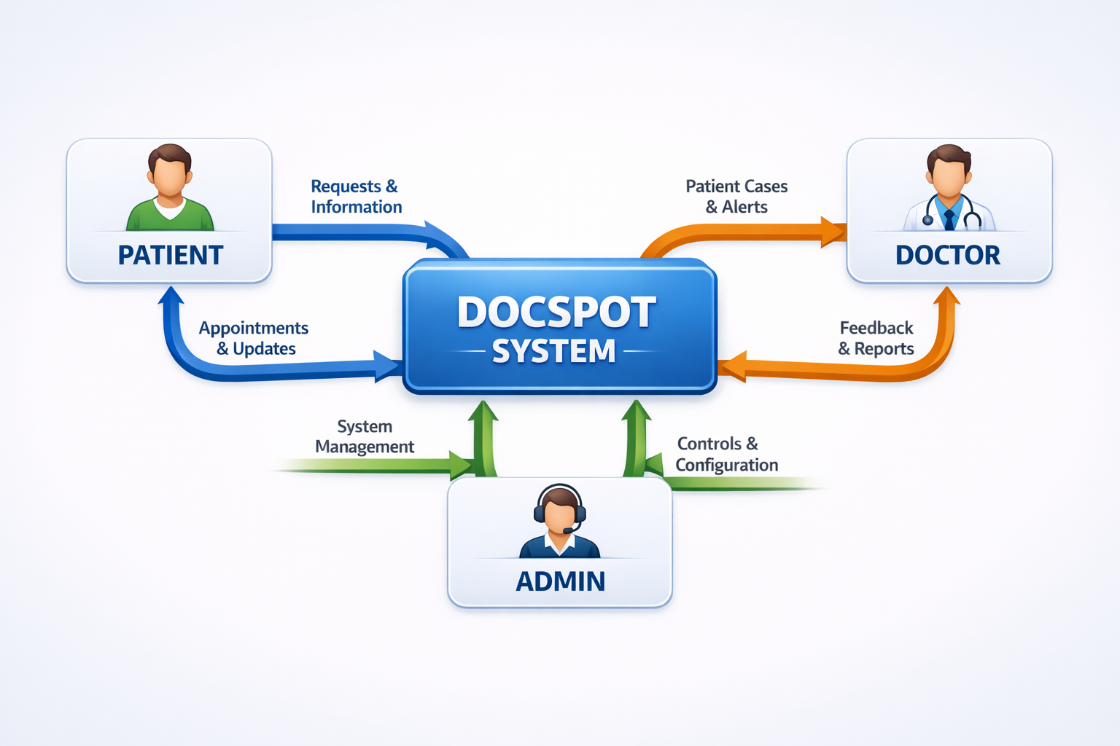

**External Entities:**

1. Patient - Books and manages appointments
2. Doctor - Manages schedule and appointments
3. Admin - Verifies doctors and monitors platform

**Level 1 DFD - Patient Processes**

**Processes:**

1. 1.0 Register - Patient creates account with email/password
2. 2.0 Login - Patient authenticates using credentials
3. 3.0 Browse Doctors - Search and filter doctors by specialization
4. 4.0 Book Appointment - Select date/time and book
5. 5.0 View/Cancel Appointments - Manage existing bookings

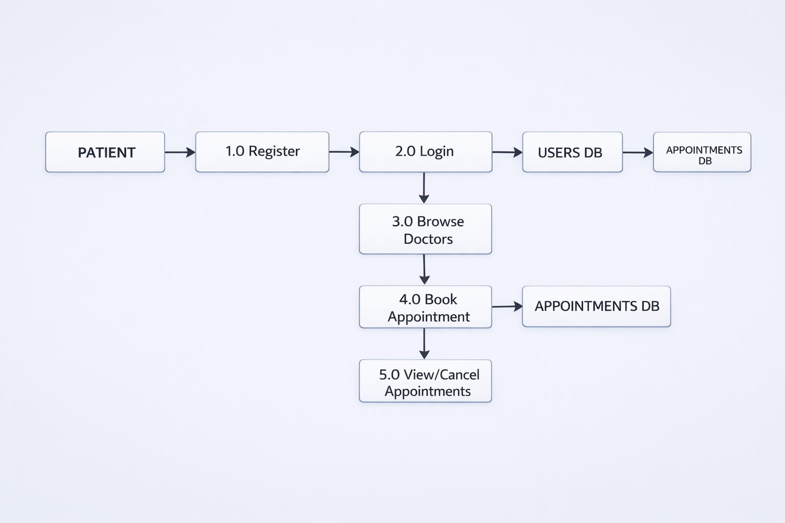

**Level 1 DFD - Doctor Processes**

**Processes:**

1. 6.0 Register (Pending) - Doctor applies with pending status
2. 7.0 Login - Doctor authenticates
3. 8.0 View Appointments - See all appointment requests
4. 9.0 Approve/Reject - Update appointment status

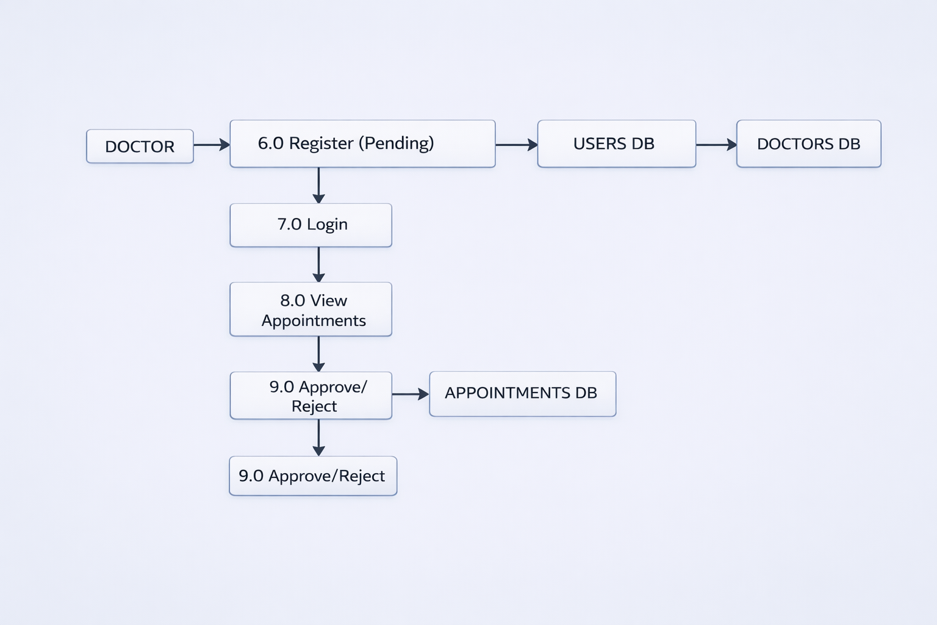

**Level 1 DFD - Admin Processes**

**Processes:**

1. 10.0 Login - Admin authenticates
2. 11.0 View Pending Doctors - See doctor applications

12. 12.0 Approve/Reject Doctor - Update doctor status  
13. 13.0 View All Users - Monitor platform users  
14. 14.0 View All Appointments - Overview of all bookings

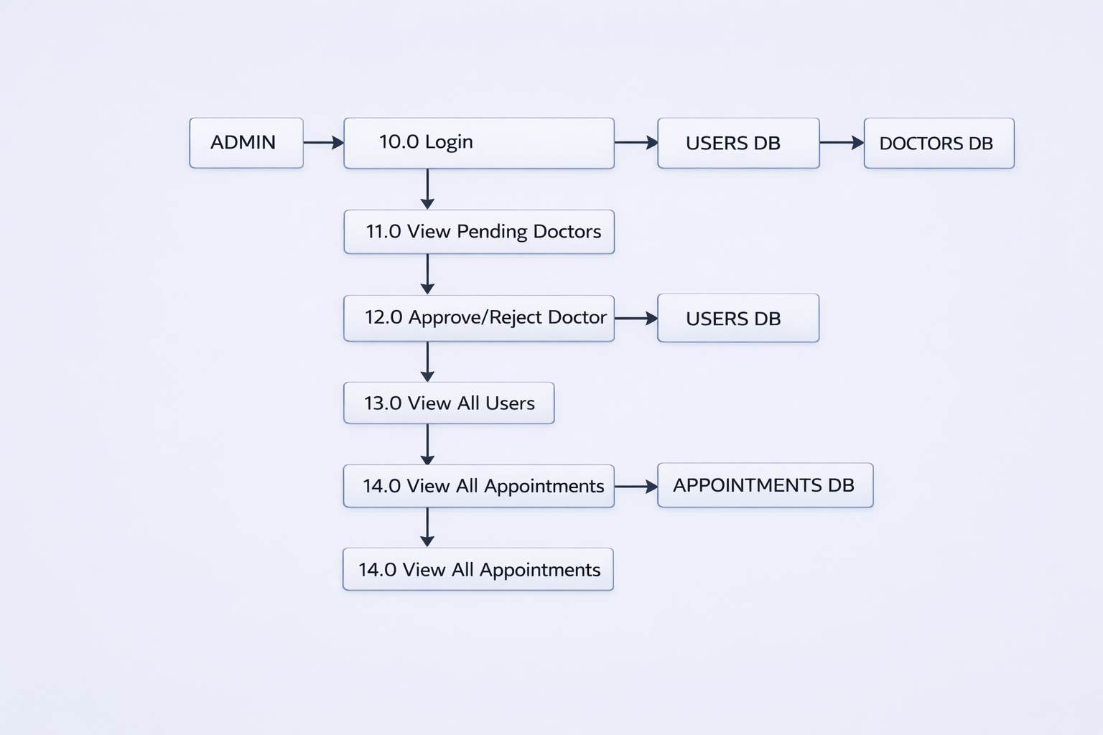

**User Stories**

Use the below template to list all the user stories for the product.

| **User Type** | **Functional Requirement (Epic)** | **User Story Number** | **User Story / Task** | **Acceptance Criteria** | **Priority** | **Release** |
| --- | --- | --- | --- | --- | --- | --- |
| **Patient** | Registration | US-P-01 | As a patient, I can register using my email, password, and phone number | I can access my dashboard after registration | High | Sprint-1 |
|  | Login | US-P-02 | As a patient, I can log in using my email and password | I am redirected to my dashboard | High | Sprint-1 |
|  | Browse Doctors | US-P-03 | As a patient, I can view all approved doctors with their specializations | List of doctors displays with names and 5-4+  /*specialties | High | Sprint-1 |
|  |  | US-P-04 | As a patient, I can filter doctors by specialization | Only doctors of selected specialty are shown | High | Sprint-1 |
|  |  | US-P-05 | As a patient, I can view doctor details including fees and experience | Doctor profile shows complete information | High | Sprint-1 |
|  | Book Appointment | US-P-06 | As a patient, I can select a date and time to book an appointment | Date picker and time slots are available | High | Sprint-1 |
|  |  | US-P-07 | As a patient, I can upload medical documents while booking | Files can be uploaded and attached to appointment | Medium | Sprint-1 |
|  |  | US-P-08 | As a patient, I receive confirmation after booking | Success message with appointment details appears | High | Sprint-1 |
|  | Manage Appointments | US-P-09 | As a patient, I can view all my appointments in history | My Appointments page shows all bookings | High | Sprint-1 |
|  |  | US-P-10 | As a patient, I can see appointment status (pending/approved/rejected) | Status badges clearly indicate current state | High | Sprint-1 |
|  |  | US-P-11 | As a patient, I can cancel my pending appointment | Appointment status changes to "cancelled" | High | Sprint-1 |
|  | Profile | US-P-12 | As a patient, I can update my profile information | Changes are saved successfully | Medium | Sprint-1 |
|  | Logout | US-P-13 | As a patient, I can securely logout | Session ends and I am redirected to home | High | Sprint-1 |
| **Doctor** | Registration | US-D-01 | As a doctor, I can register with my details (name, email, phone, specialization) | Account is created with "pending" status | High | Sprint-1 |
|  | Login | US-D-02 | As a doctor, I can log in using my email and password | I am redirected to doctor dashboard | High | Sprint-1 |
|  | Profile Management | US-D-03 | As a doctor, I can complete my profile with qualifications and experience | Profile information is saved | High | Sprint-1 |
|  |  | US-D-04 | As a doctor, I can set my consultation fees | Fees are displayed in my profile | High | Sprint-1 |
|  |  | US-D-05 | As a doctor, I can set my available timings for each day of week | Timings are saved and displayed | High | Sprint-1 |
|  | Appointment Management | US-D-06 | As a doctor, I can view all appointment requests | List of appointments with patient details is shown | High | Sprint-1 |
|  |  | US-D-07 | As a doctor, I can approve pending appointments | Status updates to "approved" and patient is notified | High | Sprint-1 |
|  |  | US-D-08 | As a doctor, I can reject appointments I cannot accommodate | Status updates to "rejected" | High | Sprint-1 |
|  |  | US-D-09 | As a doctor, I can mark completed appointments | Status updates to "completed" | Medium | Sprint-1 |
|  | Dashboard | US-D-10 | As a doctor, I can see counts of pending/approved/completed appointments | Dashboard shows statistics | Medium | Sprint-1 |
|  | Logout | US-D-11 | As a doctor, I can securely logout | Session ends and I am redirected to home | High | Sprint-1 |
| **Admin** | Login | US-A-01 | As an admin, I can log in with my credentials | I am redirected to admin dashboard | High | Sprint-1 |
|  | Doctor Management | US-A-02 | As an admin, I can view all pending doctor applications | List of pending doctors is displayed | High | Sprint-1 |
|  |  | US-A-03 | As an admin, I can view complete doctor details for verification | Doctor profile with all information is shown | High | Sprint-1 |
|  |  | US-A-04 | As an admin, I can approve qualified doctors | Doctor status updates to "approved" | High | Sprint-1 |
|  |  | US-A-05 | As an admin, I can reject unqualified doctors | Doctor status updates to "rejected" | High | Sprint-1 |
|  | User Management | US-A-06 | As an admin, I can view all registered users | List of patients and doctors is displayed | Medium | Sprint-1 |
|  | Appointment Oversight | US-A-07 | As an admin, I can view all appointments on the platform | Complete appointment list is displayed | Medium | Sprint-1 |
|  |  | US-A-08 | As an admin, I can filter appointments by status | Filtered results are shown | Medium | Sprint-1 |
|  | Dashboard | US-A-09 | As an admin, I can see platform statistics (total users, doctors, appointments) | Dashboard shows key metrics | High | Sprint-1 |
|  |  | US-A-10 | As an admin, I can see pending approvals count | Dashboard shows pending doctors count | High | Sprint-1 |
|  | Logout | US-A-11 | As an admin, I can securely logout | Session ends and I am redirected to home | High | Sprint-1 |